**Lease Management**

1. **Project Overview**

This project focuses on the development of a "Lease management" using Salesforce. This project is to design and implement a comprehensive lease management system within Salesforce that allows businesses to efficiently manage the lifecycle of lease agreements, from initial setup through payments, renewals, and terminations. The system should automate tasks, centralize lease data, and provide analytics for decision-making.

Through this project, the aim is to:

* + Centralized Lease Data.
  + Lease Lifecycle Management**.**
  + Automated Reminders & Alerts**.**
  + Payment Tracking**.** • Custom Reporting & Analytics**.**

1. **Objectives**

**Business Goals:**

* 1. Increase Operational Efficiency.
  2. Enhance Data Accuracy & Visibility.
  3. Improve Financial Control & Reporting.
  4. Ensure Compliance & Risk Reduction.

**Specific Outcomes:**

* + A user-friendly bussiness portal integrated into Salesforce.
  + Automated Lease Workflow Management.
  + Improved Payment Tracking and Financial Visibility.• Increased Compliance & Risk Management.

# Salesforce Key Features and Concepts Utilized

1. **Salesforce Objects**

Custom objects for o Tenant. o Property.

* + payment for tenant.
  + lease.

1. **Process Automation**

**1. Payment Schedule workflow**:

Automate the generation of payment schedules based on lease terms, payment frequency, and amounts.

* Flows for email sending for payment detail and approval processes.
* Apex class and Apex Triggers for avoid duplicate property .

**2.Billing & Payment Processing:**

* Scheduled Flows can automatically create recurring billing records based on the lease schedule.
* Use **Apex triggers** to update the status of payments and send out reminders for overdue payments.

**3. Lease Notifications & Alerts:**

Use **Process Builder** or **Flow** to send notifications or emails to tenants or leasing agents for important lease-related events like:

o Lease expiration o Payment reminders o Insurance verification dates o Maintenance schedules

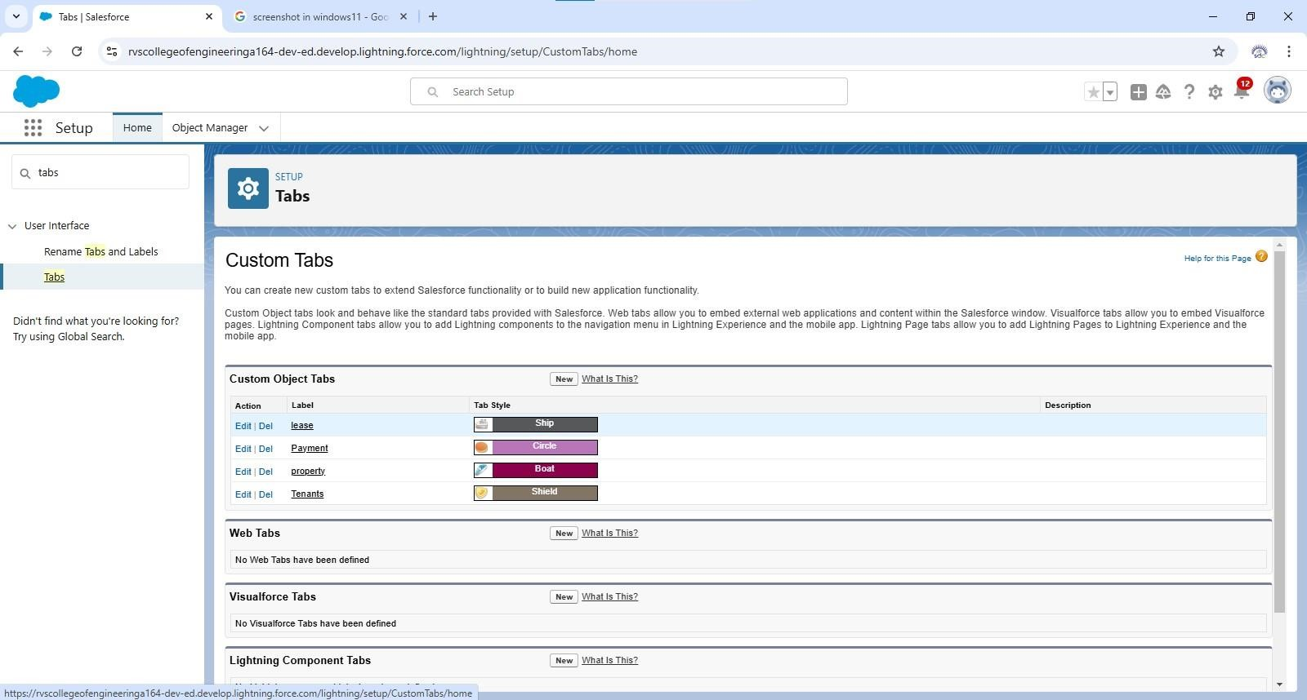

# 4.Detail steps to solution design

## Lease Agreement (Custom Object)

Custom objects: Lease, property,payment for tenant,tenant.

* **Status** (Picklist: Active, Expired, Renewed, Terminated) – Current status of the lease.
* **Lease Name** (Text) – Unique identifier for the lease.

## 2.Tenant ( Custom Object)

* **Tenant Name** (Text) – Name of the tenant or business. o **Tenant Type** (Picklist: Individual, Business) – Type of tenant.
* **Contact Information** (Phone, Email, Address) – Tenant’s contact details.

**3. Relationships Between Objects**

* **Lease Agreement** has a **Lookup relationship** to **Tenant** (Account or Custom Tenant object) and **Property** (Custom object).
* **Lease Payment** has a **Lookup relationship** to **Lease Agreement**.

## 4.Lease Payment (Custom Object)

* **Payment Date** (Date) – Date when the payment is due.
* **Amount Paid** (Currency) – The amount the tenant paid.
* • **Payment Method** (Picklist: Credit Card, Bank Transfer, Cash, etc.) – Method used to make the payment.

# 5.Testing and validation

**1.User Interface Testing:**

* Validated UI components across desktop and mobile platforms.
* Tested workflows for booking, inventory updates, and reporting.

**2.Integration Testing:**

* Validated integrations with external systems like payment gateways and SMS services.

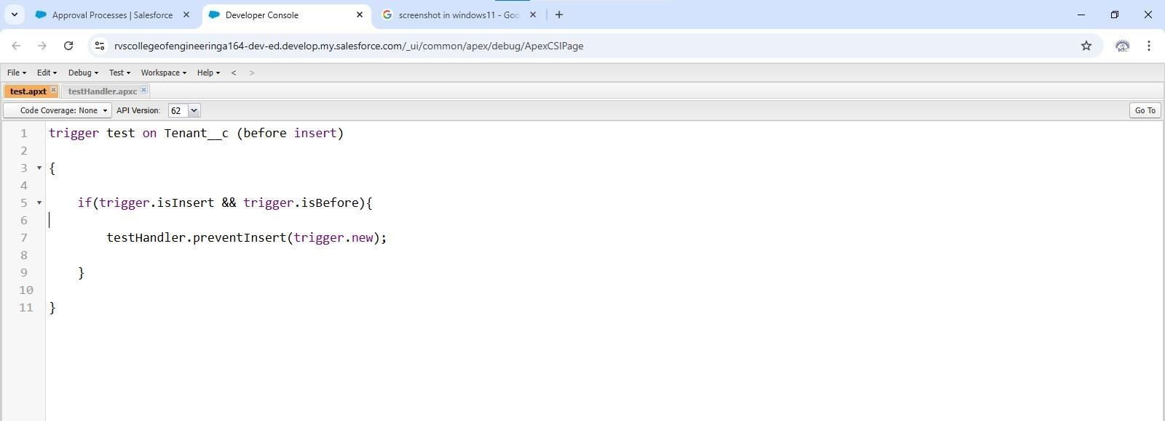

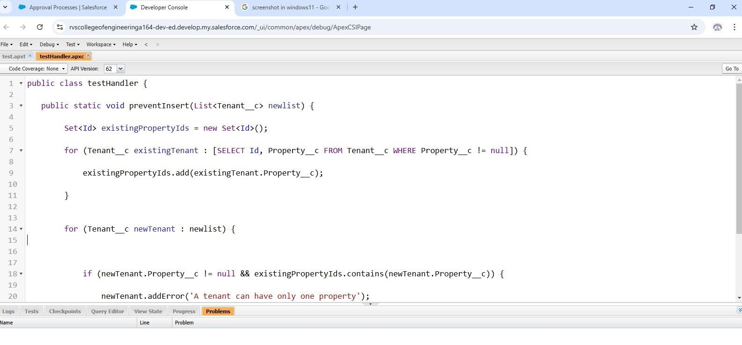

# 6.Key Scenarios Addressed by Salesforce in the Implementation Project 3. Lease Renewals & Extensions

o To identify leases that are due for renewal. o Lease expired can renewal and extension.

## 2.Automated Email Notifications

* Real-time updates to inventory upon part usage during services.

**3.Service Tracking:**

* Technicians can update service status, and customers receive live updates.

o

**4.Compliance Tracking with Custom Fields**:

* Use custom fields and validation rules to track compliance-related data, such as whether tenants have submitted proof of insurance, completed necessary maintenance, or adhered to property usage guidelines.

# 7.Conclusion

The lease management built on Salesforce enhances the operational efficiencies, enhanced automation, and improved customer experience for organizations involved in property leasing, equipment leasing, or any business managing complex lease agreements. Salesforce offers a robust and flexible platform that can be customized to address a wide range of challenges .